7.2.12 Editors - 3D View - Tool Shelf - Grease Pencil - Edit Mode
Tool Shelf - Grease Pencil - Edit Mode 3
Tweak, Select, Transform, 3D Cursor Measure and Annotate tools 3
Extrude 3
Snapping 3
Precision movement 3
Header Values 3
Move without Widget 3
Limit Axis 4
Tool Settings 4
Axis Type 4
Drag 4
Active Tool 4
Tweak, Select Box, Circle and Lasso 4
Last Operator Extrude Stroke Points 4
Move X, Y Z 4
Orientation 5
Proportional editing 5
Proportional Falloff 5
Proportional Size 5
Connected 5
Projected(2D) 5
Radius 5
Snapping 5
Precision movement 5
Header Values 5
Last Operator Transform 5
Transform X, Y Z 5
Axis 6
Orientation 6
Proportional editing 6
Proportional Falloff 6
Proportional Size 6
Connected 6
Projected(2D) 6
Bend 6
Snapping 6
Precision movement 6
Header Values 6
Shear / To Sphere Tools group 7
Shear 7
Snapping 7
Precision movement 7
Header Values 7
Hotkeys 7
Last Operator Shear 7
Offset 7
Axis 7
Axis Ortho 7
Orientation 7
Proportional editing 7
Proportional Falloff 7
Proportional Size 7
Connected 8
Projected(2D) 8
To Sphere 8
Snapping 8
Precision movement 8
Header Values 8
Last Operator To Sphere 8
Offset 8
Proportional editing 8
Proportional Falloff 8
Proportional Size 8
Connected 8
Projected(2D) 8

Tool Shelf - Grease Pencil - Edit Mode
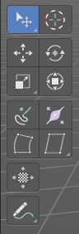
Here you can find tools to edit the curve geometry of the grease pencil strokes.

Tweak, Select, Transform, 3D Cursor Measure and Annotate tools

The tweak, select, transform, 3d cursor, measure and annotate tools at the end of the list are explained in the chapter 7.1.1 Editors - 3D View - Tool Shelf - Object Mode. We won't cover this tools again here.

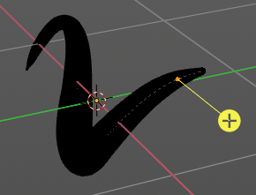
Extrude
Extrude out selected curve points.

Snapping
Holding down Ctrl activates temporary global snapping.

Precision movement
When you hold down shift, then you will have a much slower but also much preciser movement.

Header Values
When you move the mouse then you will see some values in the header, which defines the current position of the object.
The value m stands for the default metric system. Meters. You can change the units in the Properties editor in the Scene properties in the Units panel. When you choose kilometers here then you will see a km instead m.
The value D stands for the distance of the current selected axis. This can also be two axis. Then you have two d values. The value in the brackets is then the direct distance to the starting point.
These values are always relative to the starting point. You always start with zero, regardless of the real world position.

Move without Widget
You don't have to use the widget to move the object. You can also click aside of it, and drag the object around. The mouse turns into a move cursor. The standard behaviour then is to move in screen space. When you want to move into a specific axis, then press X or Y or Z to limit the movement to this axis.

Limit Axis
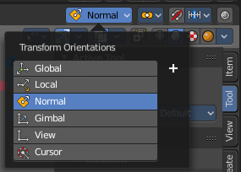
When you want to move along a specific axis, then press X or Y or Z to limit the movement to this axis. You usually start in global orientation. But you can change this in the Orientation settings.
By holding down the mouse button and pressing the X, Y or Z key twice you can toggle this to local. But also to other orientations. This depends in what orientation you start. With normal you can toggle that way between Normal and Global.

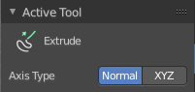
Tool Settings

Axis Type
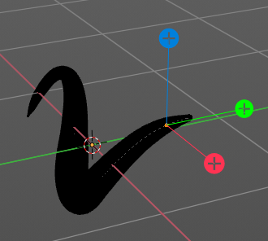
You can choose between the regular axis type. That's the yellow widget with just one handler. It always points in the direction of the middled normals of the selection.
Or you can use the XYZ axis type. That's a handler with three axis. This widget can be aligned with the transform orientation methods.

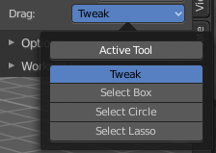
Drag
When you click at the widget of the active tool, then you perform the tool action. Adjust what should happen when you click outside of the widget, in the empty area.

Active Tool
When you click off the widget then the click still does the same than clicking at the widget. It performs the active tool.

Tweak, Select Box, Circle and Lasso
When you choose this options then you will set the off click to the different select methods. Whereas tweak works more than a move tool then. Tweak is the default.

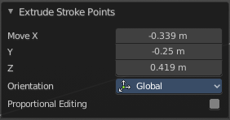
Last Operator Extrude Stroke Points

Move X, Y Z
The position. Attention, the actual world orientation and rotation does not matter here. It always starts with a value of zero, and moves relative to this zero then. For the actual location values have a look in the sidebar in the transform panel.


Orientation
The widget can have different orientations. The menu items should be self explaining.


Proportional editing
Enables proportional editing. Activating proportional editing reveals further settings.

Proportional Falloff
Adjust the falloff methods.

Proportional Size
See and adjust the falloff radius.

Connected
The proportional falloff gets calculated for connected parts only.

Projected(2D)
The proportional falloff gets calculated in the screen space. Depth doesn't play a role. When it's in the radius, then it gets calculated.

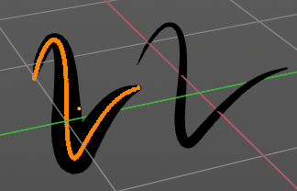
Radius
Increases the thickness of the stroke for the selected curve points.

Snapping
Holding down Ctrl activates temporary global snapping.

Precision movement
When you hold down shift, then you will have a much slower but also much preciser movement.

Header Values
When you move the mouse then you will see some values in the header, which shows the current scale factor. This value is relative to the starting value, which always starts with 1.

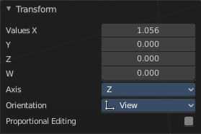
Last Operator Transform

Transform X, Y Z
The scale factor. Actually just the Value X does really matter. The other values have no effect.

Axis
Define an axis to scale. But this setting has no effect.

Orientation
The widget can have different orientations. The menu items should be self explaining.

Proportional editing
Enables proportional editing. Activating proportional editing reveals further settings.

Proportional Falloff
Adjust the falloff methods.

Proportional Size
See and adjust the falloff radius.

Connected
The proportional falloff gets calculated for connected parts only.

Projected(2D)
The proportional falloff gets calculated in the screen space. Depth doesn't play a role. When it's in the radius, then it gets calculated.

Bend
Bends the selection.

Snapping
Holding down Ctrl activates temporary global snapping.

Precision movement
When you hold down shift, then you will have a much slower but also much preciser movement.

Header Values
When you move the mouse then you will see some values in the header, which shows the current scale factor. This value is relative to the starting value, which always starts with 1.

Shear / To Sphere Tools group

Shear

Snapping
Holding down Ctrl activates temporary global snapping.

Precision movement
When you hold down shift, then you will have a much slower but also much preciser movement.

Header Values
When you move the mouse then you will see some values in the header, which shows the current scale factor. This value is relative to the starting value, which always starts with 1.

Hotkeys
As shown in the header, you can press X or Y to set the shear axis.

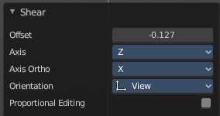
Last Operator Shear

Offset
The shear offset. This value always starts at zero.

Axis
Define the first axis for the shear transformation.

Axis Ortho
Define the second axis for the shear transformation

Orientation
The widget can have different orientations. The menu items should be self explaining.

Proportional editing
Enables proportional editing. Activating proportional editing reveals further settings.

Proportional Falloff
Adjust the falloff methods.

Proportional Size
See and adjust the falloff radius.

Connected
The proportional falloff gets calculated for connected parts only.

Projected(2D)
The proportional falloff gets calculated in the screen space. Depth doesn't play a role. When it's in the radius, then it gets calculated.

To Sphere
Transforms the selection into a sphere shape.

Snapping
Holding down Ctrl activates temporary global snapping.

Precision movement
When you hold down shift, then you will have a much slower but also much preciser movement.

Header Values
When you move the mouse then you will see some values in the header, which shows the current to sphere factor. This value is relative to the starting value, which always starts with 0.

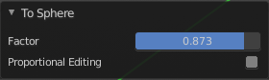
Last Operator To Sphere

Offset
The to sphere factor. This value is relative to the starting value, which always starts with 0.

Proportional editing
Enables proportional editing. Activating proportional editing reveals further settings.

Proportional Falloff
Adjust the falloff methods.

Proportional Size
See and adjust the falloff radius.

Connected
The proportional falloff gets calculated for connected parts only.

Projected(2D)
The proportional falloff gets calculated in the screen space. Depth doesn't play a role. When it's in the radius, then it gets calculated.

Transform Fill
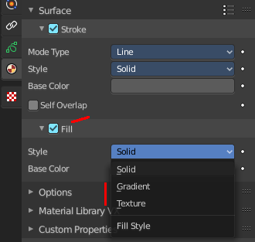
Change the Translation, Rotation and scale of strokes fill.
This tool is connected with the material settings. And works with Fill style Gradient and Texture.

Tool Settings
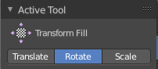
Adjust the translation mode to Translate, Rotate or Scale.

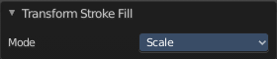
Last Operator Transform Stroke Fill

Mode
Adjust the translation mode to Translate, Rotate or Scale.

